Chapter 10, Problem 3.

Determine v_{o} in the circuit of Fig. 10.52.

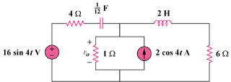

Figure 10.52
For Prob. 10.3.

